|  |  |  |  |  |  |  |  |
| --- | --- | --- | --- | --- | --- | --- | --- |
| Emp_ID | Name | FName | Designation | Gender | Email | Add | ID |
| Int | Varchar or  nvarchar | Varchar or  nvarchar | Varchar or  nvarchar | Varchar or  nvarchar | Varchar or  nvarchar | Varchar or  nvarchar | Varchar or  nvarchar |
| 1 | ‘Asif’ | ‘Asif’ | ‘Asif’ | ‘Asif’ | ‘Asif’ | ‘Asif’ | ‘Asif’ |
| 2 | ‘Asif’ | ‘Asif’ | ‘Asif’ | ‘Asif’ | ‘Asif’ | ‘Asif’ | ‘Asif’ |
| 4 | ‘Asif’ | ‘Asif’ | ‘Asif’ | ‘Asif’ | ‘Asif’ | ‘Asif’ | ‘Asif’ |

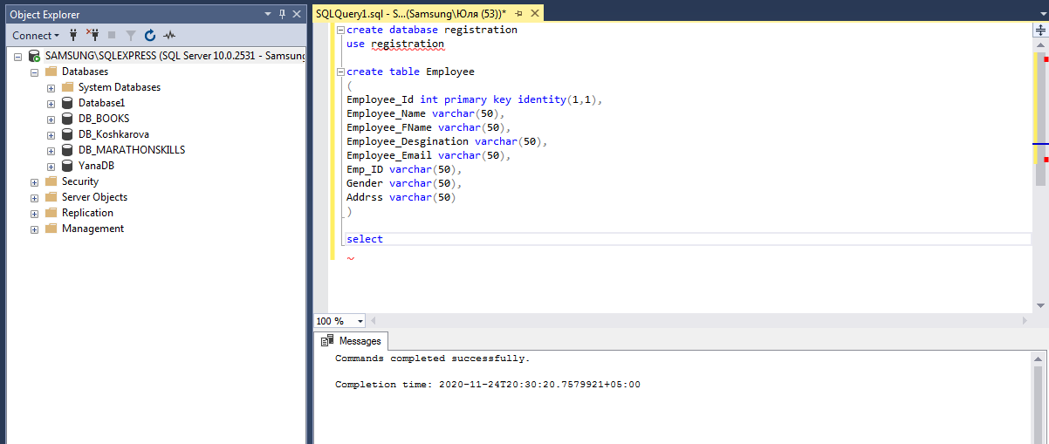

create table Employee

(

Employee_Id int primary key identity(1,1),

Employee_Name varchar(50),

Employee_FName varchar(50),

Employee_Desgination varchar(50),

Employee_Email varchar(50),

Emp_ID varchar(50),

Gender varchar(50),

Addrss varchar(50)

)

select * from Employee

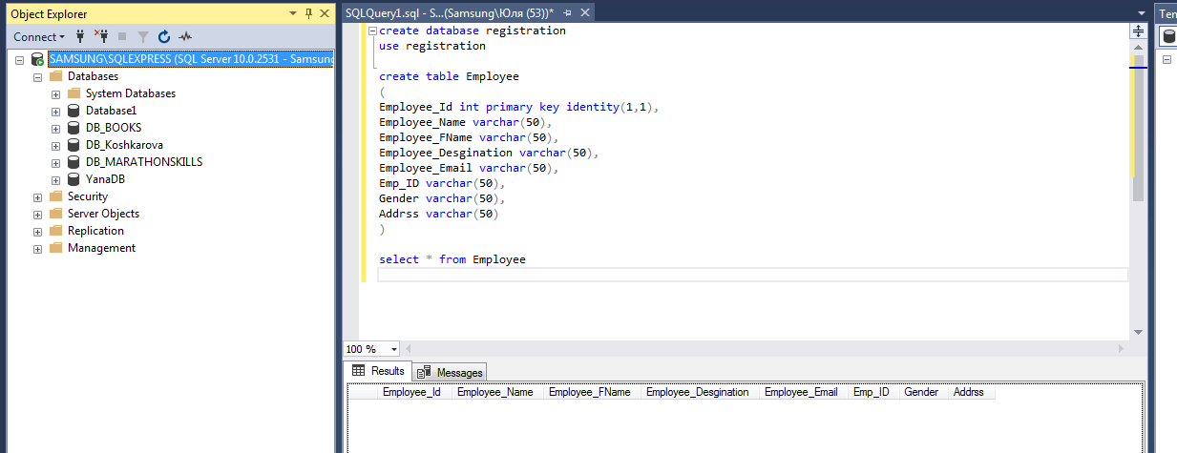

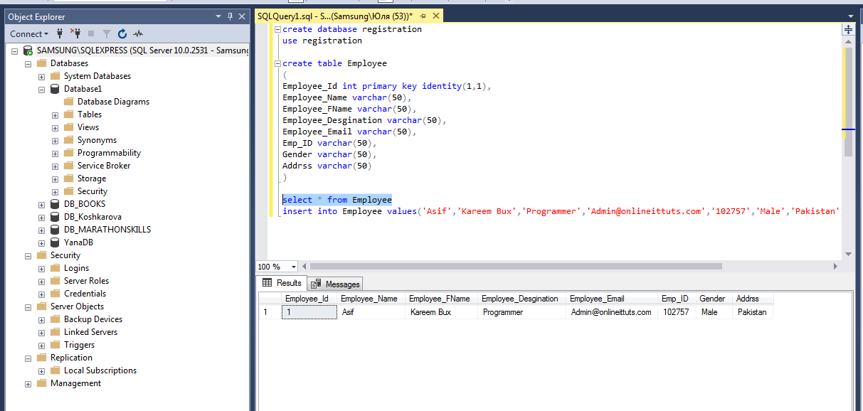

try

{

string gender;

if(rbtnMale.Checked)

{

gender = "Male";

}

else

{

gender = "Female";

}

con.Open();

cmd = new SqlCommand("insert into Employee (Employee_Name,Employee_FName,Employee_Desgination,Employee_Email,Emp_ID,Gender,Addrss) values ('" + txtName.Text + "','" + txtFName.Text + "','" + txtDesignation.Text + "','" + txtEmail.Text + "','" + txtID.Text + "','" + gender + "','" + txtAddress.Text + "') ", con);

}

catch (Exception ex)

{

MessageBox.Show(ex.Message);

}

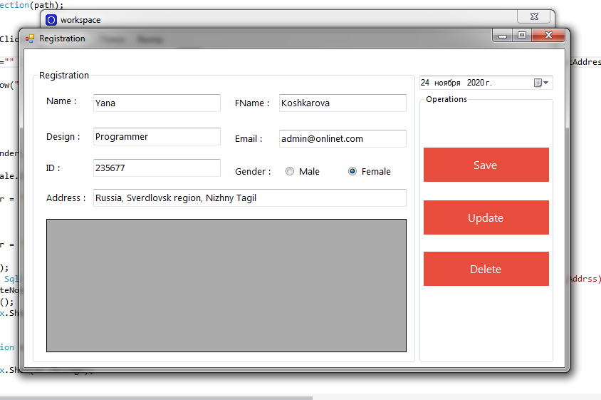

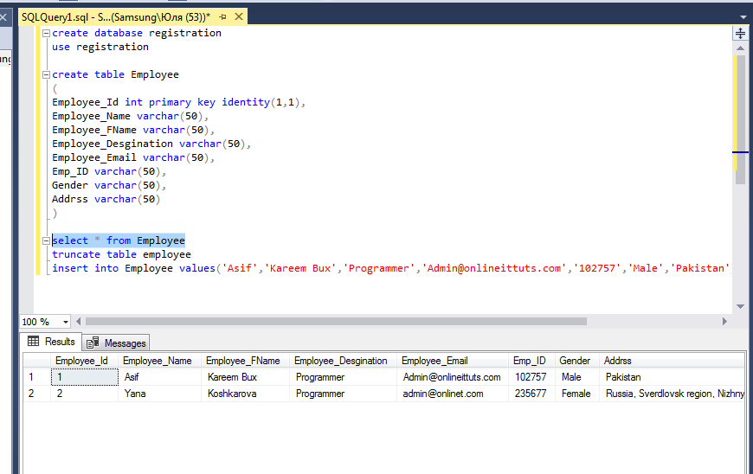

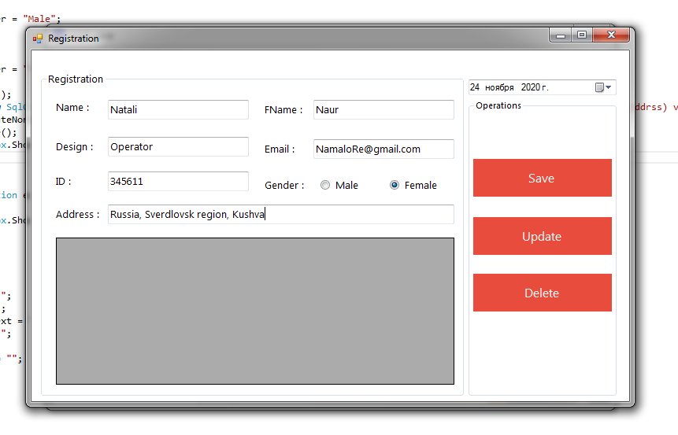

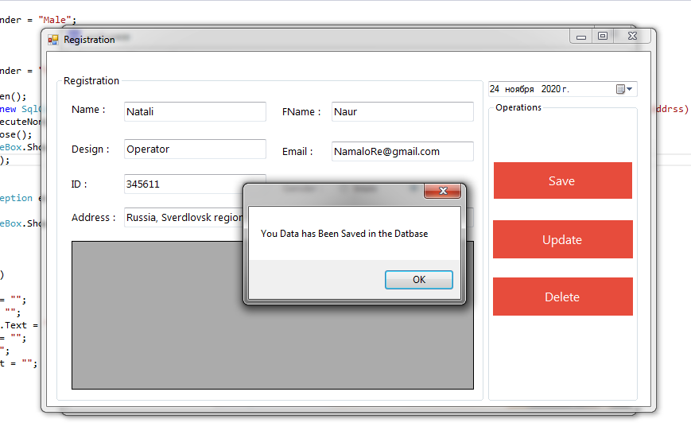

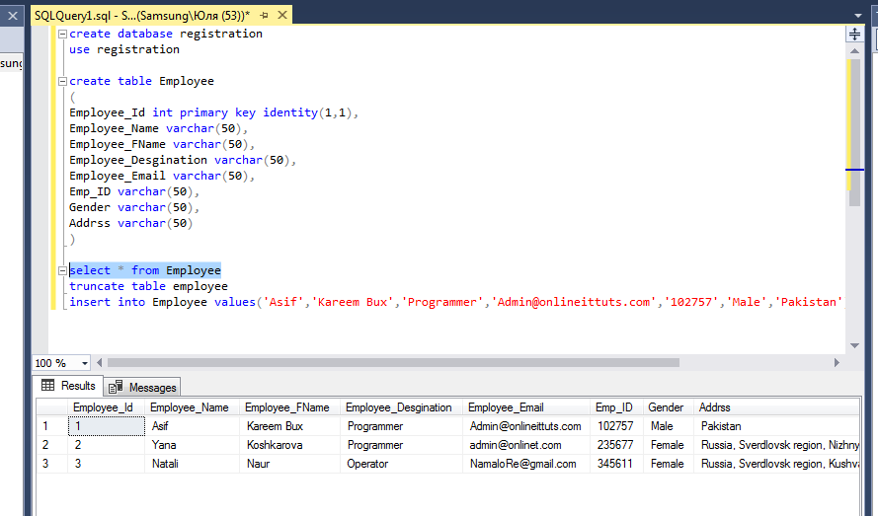

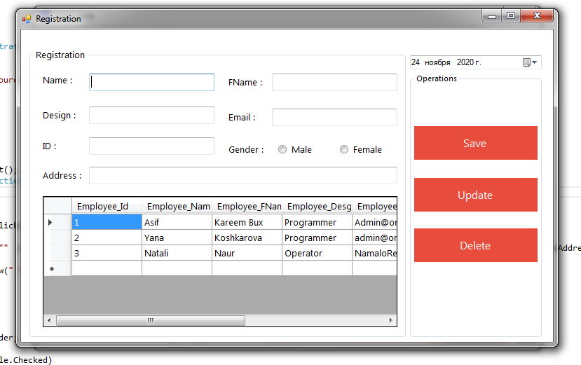

create database registration

use registration

create table Employee

(

Employee_Id int primary key identity(1,1),

Employee_Name varchar(50),

Employee_FName varchar(50),

Employee_Desgination varchar(50),

Employee_Email varchar(50),

Emp_ID varchar(50),

Gender varchar(50),

Addrss varchar(50)

)

select * from Employee

truncate table employee

insert into Employee values('Asif','Kareem Bux','Programmer','Admin@onlineittuts.com','102757','Male','Pakistan')

